**1.WRITE A C PROGRAM TO CHECK THE GIVEN NUMBER IS EVEN OR ODD.**

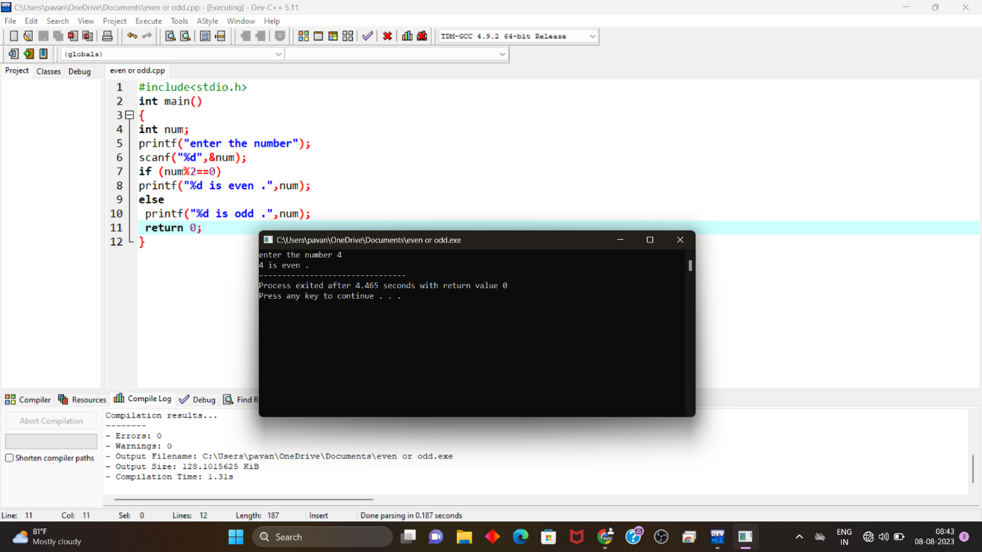

**2.WRITE A C PROGRAM TO FIND SUM OF FIRST N NUMBERS USING FOR LOOP.**

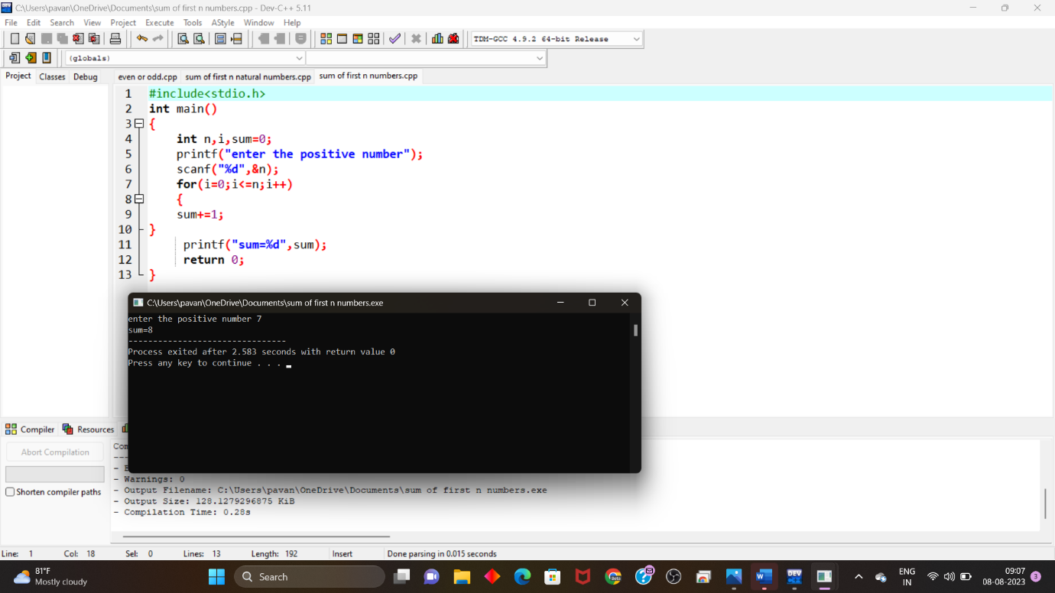

**3. WRITE A C PROGRAM TO FIND SUM OF EVEN NUMBERS USING WHILE LOOP.**



**4.WRITE A C PROGRAM TO REVERSE THE GIVEN NUMBER.**



**5.WRITE A C PROGRAM TO CHECK GIVEN NUMBER IS PALINDROME OR NOT.**

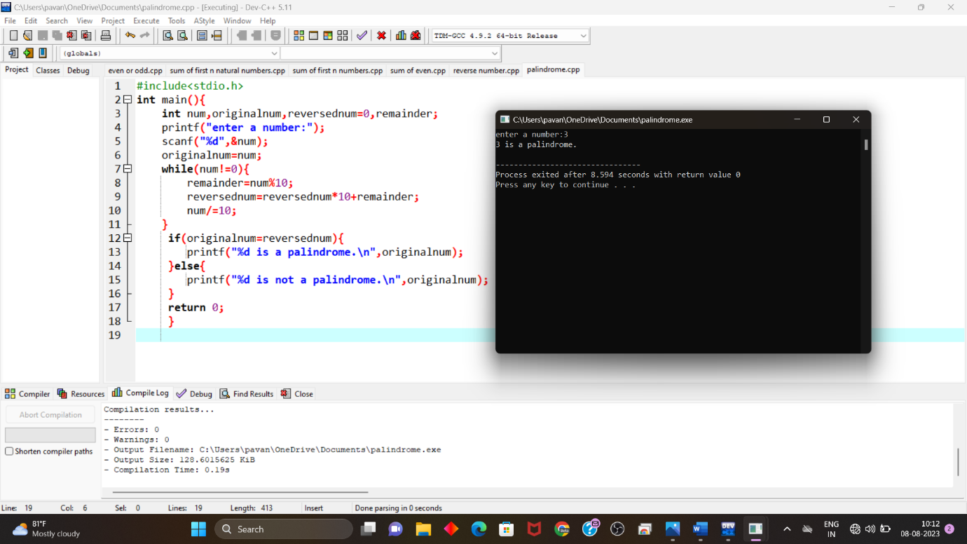

**6.WRITE A C PROGRAM TO CHECK THE GIVEN NUMBER IS ARM STRONG NUMBER OR NOT.**

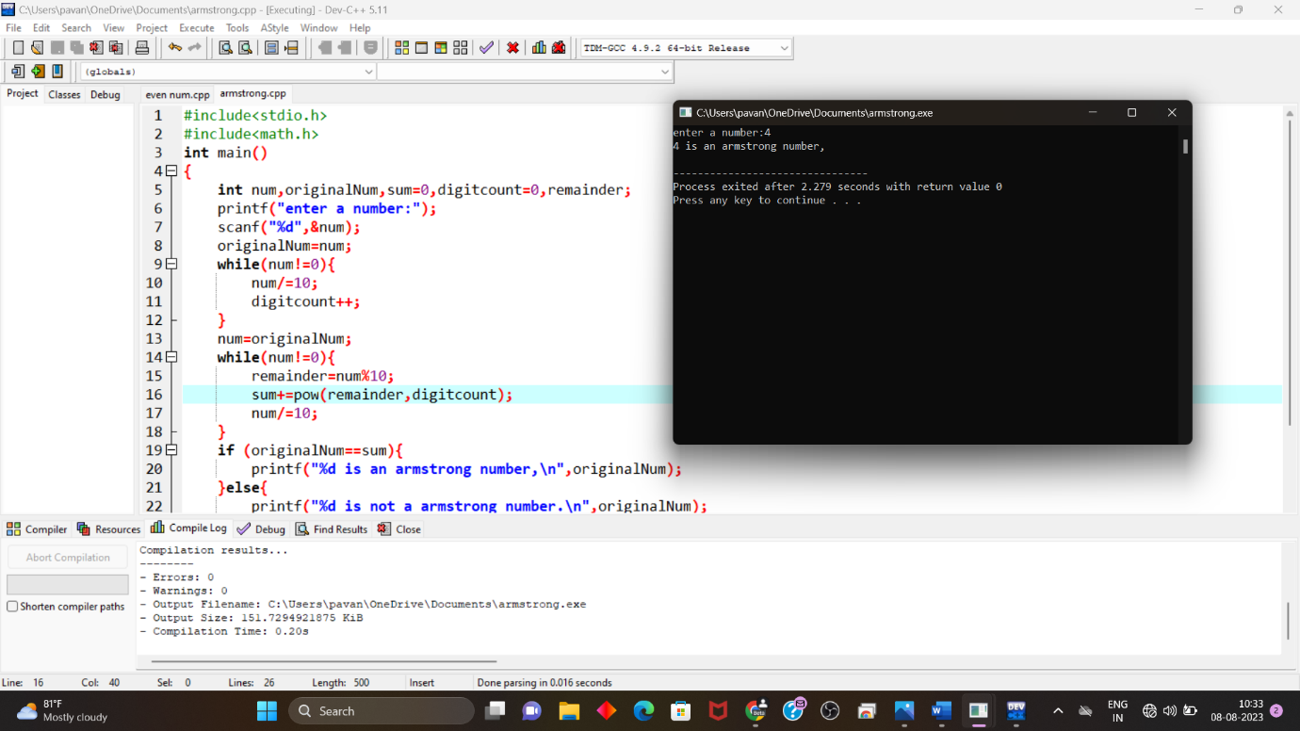

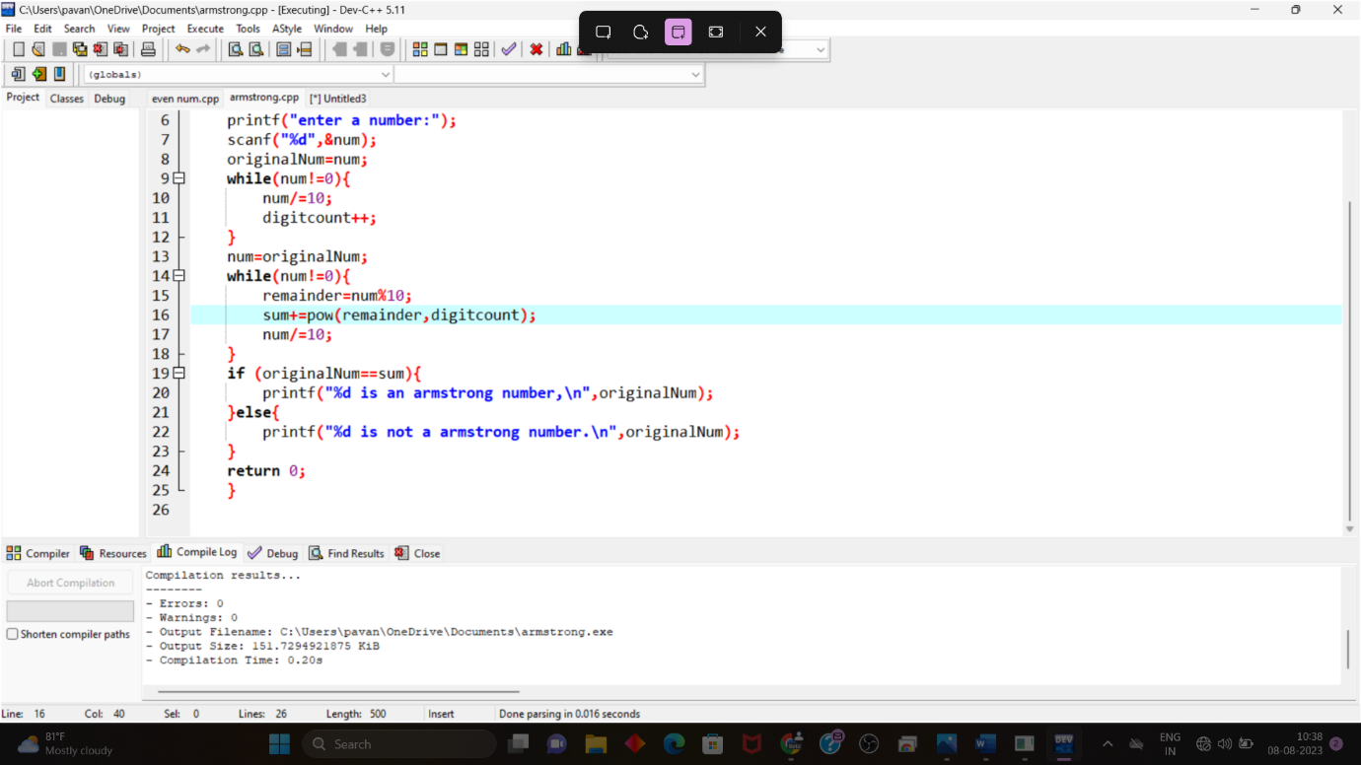

**7. WRITE A C PROGRAM TO FIND THE FACTORIAL OF THE GIVEN NUMBER IS WITHOUT RECURISION.**

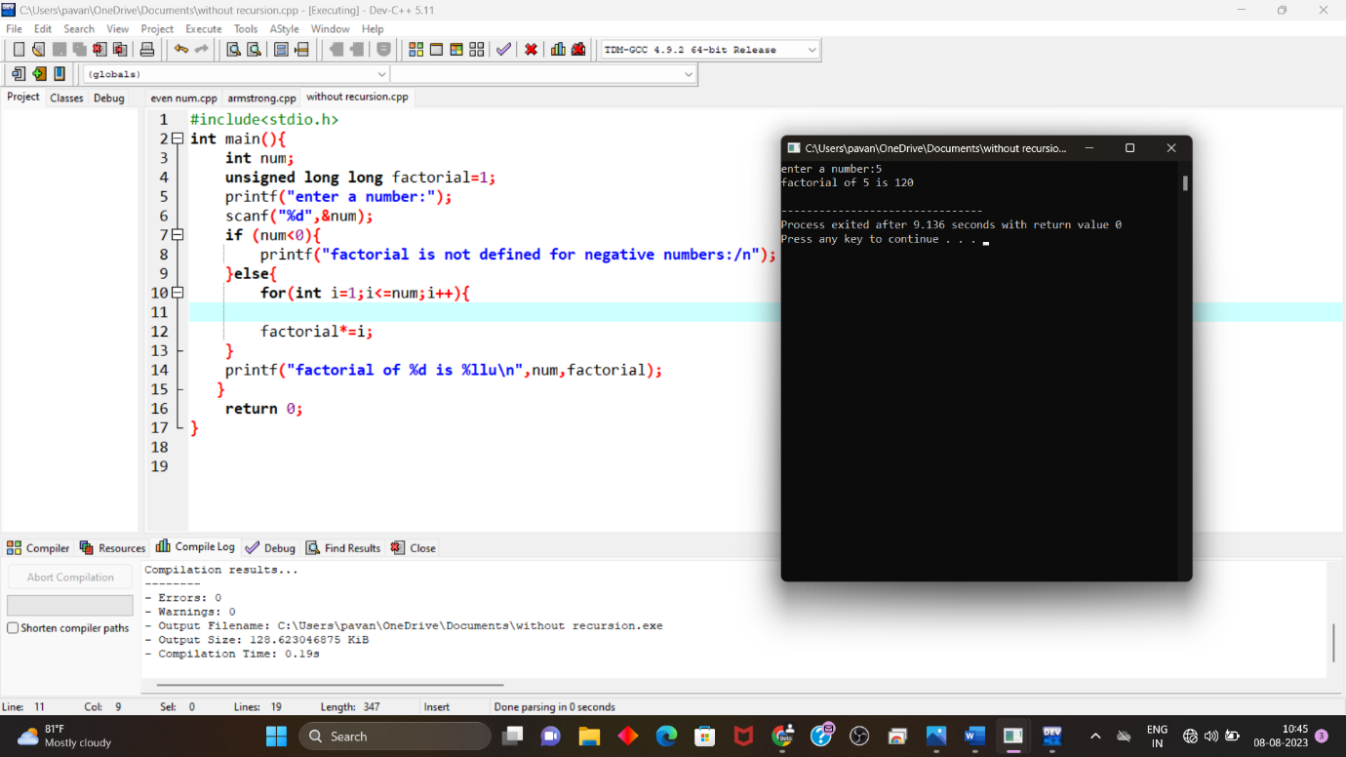

**8.WRITE A C PROGRAM TO FIND THE FACTORIAL OF THE GIVEN NUMBER IS WITH RECURISION.**

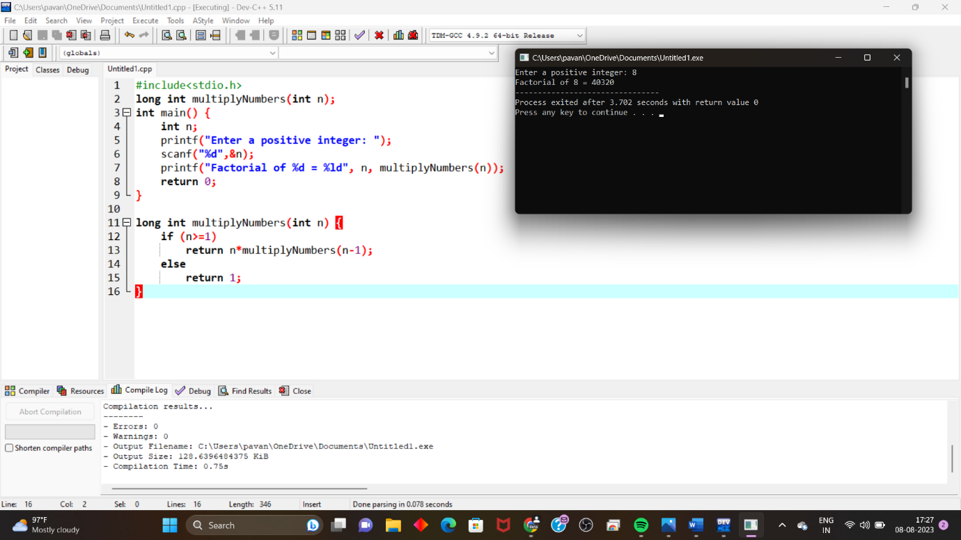

**9.WRITE A CPROGRAM TO GENERATE FIBINOOCI SERIES WITH RECURISION.**

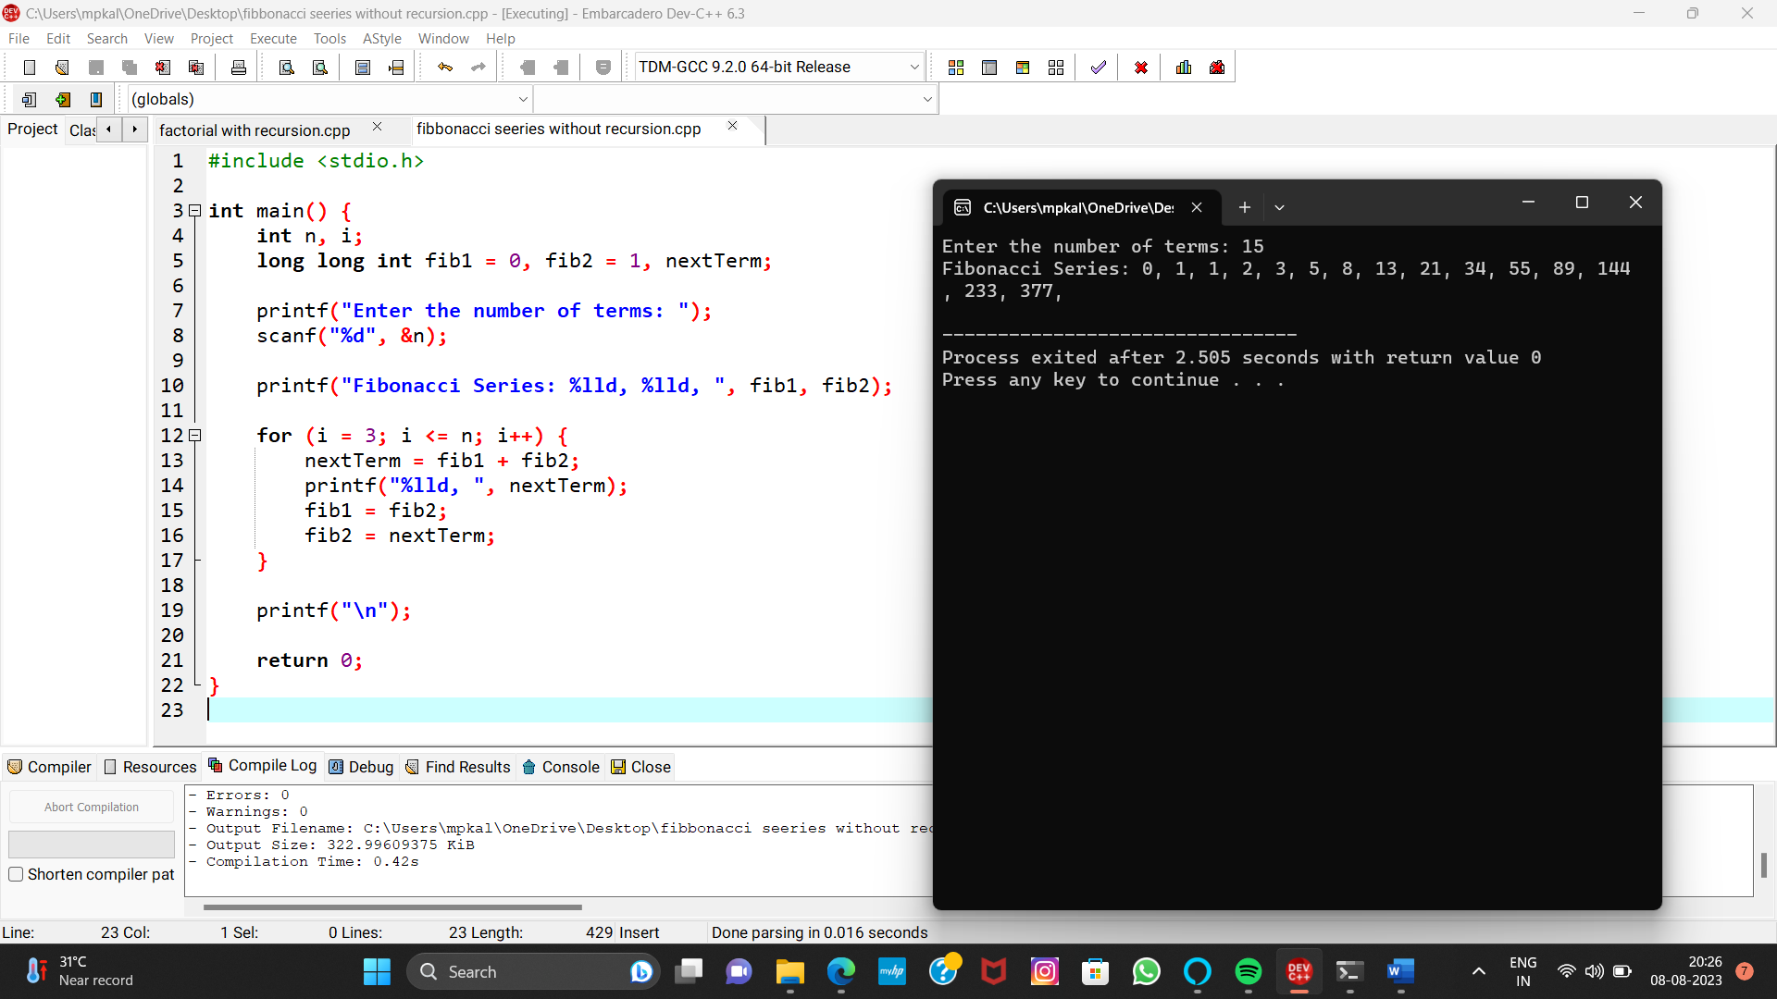

**10. write c program for Fibonacci with recursion**

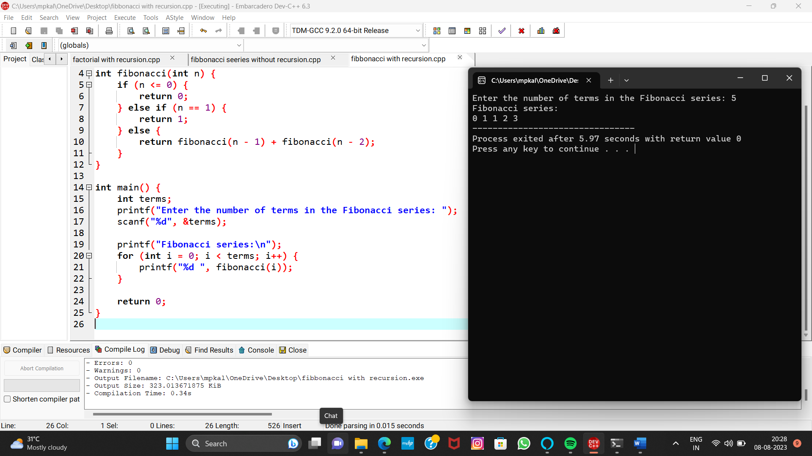

**11.write c program for linear search**

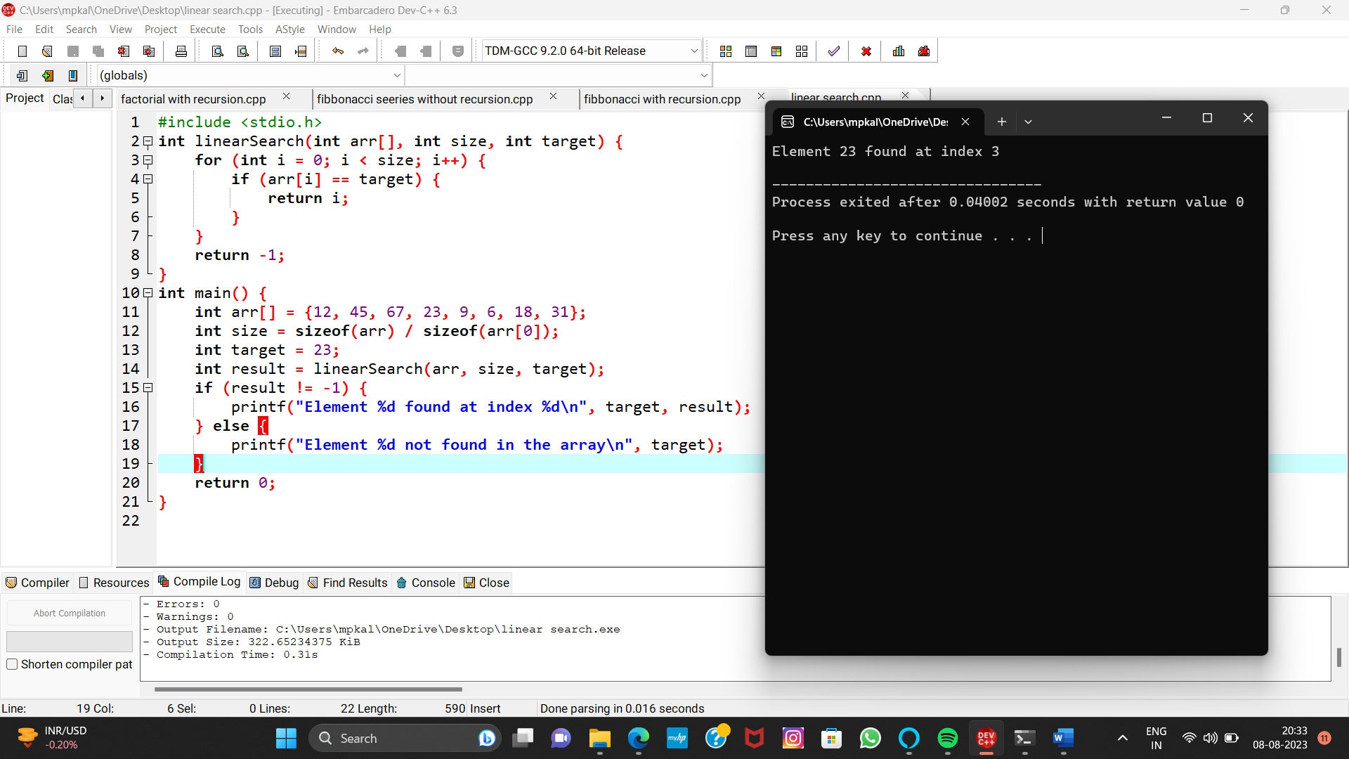

**12.write c program for fibanacci series without recursion**



